**Experiment 17**

**Lab Book:**

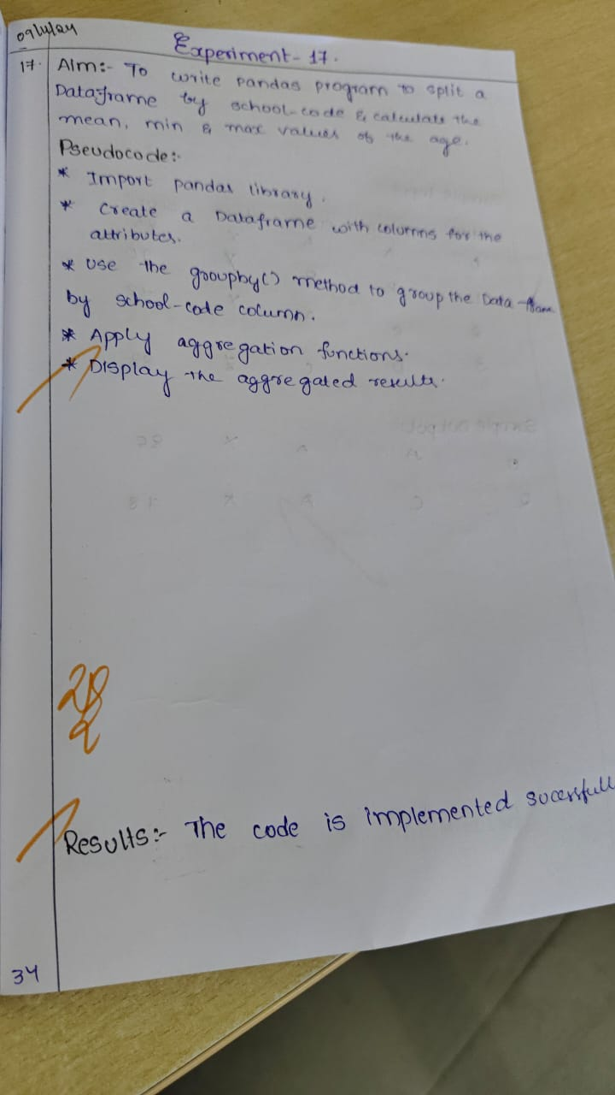

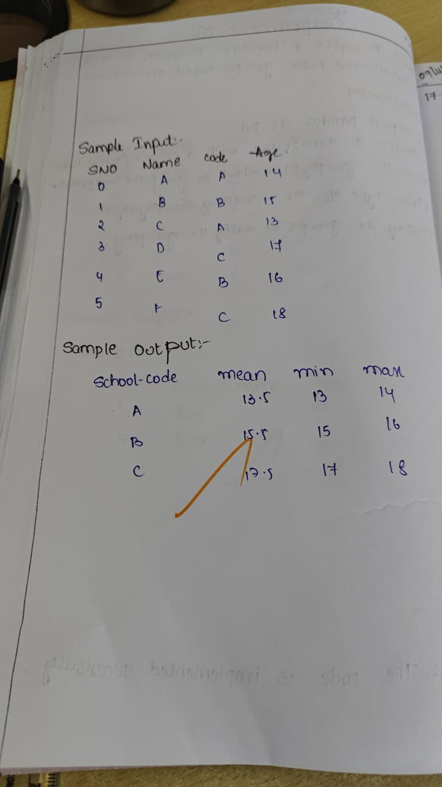

**Code:**

import pandas as pd

data = {

'student_name': ['Alice', 'Bob', 'Charlie', 'David', 'Ella', 'Frank'],

'school_code': ['A', 'B', 'A', 'C', 'B', 'C'],

'age': [14, 15, 13, 17, 16, 18]

}

df = pd.DataFrame(data)

age_stats = df.groupby('school_code')['age'].agg(['mean', 'min', 'max'])

print("Mean, min, and max age for each school:")

print(age_stats)

**Sample Output**

